Research Plan

## **Supervisor**: Jagdish Patra

## **Project title**: Artificial Neural network based prediction of stock prices

## **Group ID**: 22

## **Student name**: Ngoc Khanh Nguyen

## **Student ID**: 4957059

## April 06, 2017

Table of Contents

1. **Abstract3**
2. **Introduction3**
3. **Related works3**
4. **Project details4**
   1. **Research Questions4**
   2. **Objectives5**
5. **Methodology5**
   1. **Toolbox5**
   2. **Data collection and preprocessing6**
   3. **Neural network construction6**
   4. **Performance metrics8**
6. **Task9**
7. **Research timeline9**
8. **Abstract**

This research presents a predictive model which to forecast the closing prices of stocks using artificial neural networks (ANNs). Predicting the stocks market is considered one of the most challenging task due to the dynamic of the financial time series[1]. In recent years, as the computing power and the amount of available financial data rises remarkably, the popularity of utilizing artificial intelligence method techniques which includes ANNs has been significantly increased in this field[2]. The proposed ANNs in this research imply learning historical closing price pattern, technical and financial indicators to model the behavior and predict the future price of stocks with high accuracy. The acquired results may allow investors to plan an appropriate trading strategy in the stock market which could possibly raise their profit considerably [3, 4].

1. **Introduction**

Stock prediction is regarded as one of the most important task of financial markets. Many researches have been carried out to tackle this problem. There are three major approaches to forecast the stock price movement: technical analysis, time series forecasting and machine learning and data mining[4]. Technical analysis method focuses on company’s performance and credibility to evaluate its stock. In comparison, time series forecasting method does not take company’s performance into account but only attempt to predict future price based solely on past price[5]. The last method, machine learning and data mining which includes neural network, is the “the science of extracting useful information from large data sets or databases”[4] which could take advantage of both companies’ performance and past stock price. However, due to the non-linearity, non-stationary of financial time series data and a huge impact of unpredictable factors such as major economic and government policies, investors’ attitude and sentiment[6], stocks prediction has never ever been an easy task. Overtime, many studies have proved that neural network is a potential candidate to unveil the complex stocks price data[7]. Enke and Thaworn-wong applied ANNs for level estimation and classification. Their research showed that it was possible to gain higher profits using trading strategies lead by ANNs classification models compared to other learning models [7]. Mostafa and Mohamed constructed two neural networks and generalized regression neural network to forecast Kuwait stock market[8]. Kumar Chandar et al. suggested a model combined wavelet transform and ANNs[9]. Their findings support the use of ANNs for financial forecasting.

1. **Related works**:

This section presents brief summaries of some existing researches

* J. C. Patra et al. conducted an experiment to predict the next-day’s closing price of Exxon Mobil (energy sector), Citigroup (banking sector) and IBM (technology sector) by a supervised learning method using functional link artificial neural network (FLANN)[10]. The data was collected on daily basis from Yahoo Finance between Jan 1998 and Apr 2008. It contained 2478 samples in total. The model predicted next-day’s closing price based on 14 different features which consisted of not only open and closing prices but also industrial indices and technical indicators for higher accuracy. The structure of the FLANN network had two parts. The first part was a trigonometric functional expansion component to map the input data from low dimensional space to a higher dimensional space. The second part was a single neuron with tanh activation function. The experiment yielded a reasonably low average percentage error (APE) 1.4% to 4.5% with acceptable hit rate of 0.62.
* F. A. d. Oliveira et al. conducted an experiment using supervised neural network to predict the next-day’s closing price and possible future behavior of stock PETR4 which belong to Petrobras (energy sector) traded on the Sao Paulo Stock Exchange (BM&FBOVESPA)[11]. The data set consisted of 2384 samples during 04/01/2000 and 18/08/2009. It contained 22 features such as opening, closing price and 5, 22, 200-day exponential moving average. The structure of the neural network consisted of three layers which were 1 input layer, 1 hidden layer and 1 output layer. The number of neurons in the input layer was the window size multiplied by the number of sample set series. The hidden layer had 22 neurons which was the number of features. The number of neurons in the output layer varied by the size of the expected prediction window. The best performance of the model was obtained with 5-day window and a prediction range of 1 day with root mean square (RMS) error of 0.00129.
* G. Tingwei et al. proposed a stock closing price prediction model based on deep belief networks (DBNs) with stock daily information and stock technical indicators input preprocessed by principal component analysis (PCA)[2]. The input data was S&P500 stocks collected from Yahoo Finance from Jan 2004 to Apr 2016 which equaled to 3093 trading days. Each sample in the data set consisted of 16 features which were daily information such as open and closing price and technical indicators such as Chaikin volatility and Williams. The DBNs network had 5 layers in total which were 1 input layer, 3 hidden layers in which hidden units within each layer were not connected with each other and 1 output layer with a softmax activation function. The PCA reduced input dimension to 2. The paper compared results acquired from the proposed model with two other approaches which were basic neural network with stock daily information input and deep belief networks (DBNs) with stock daily information and stock technical indicators input to show its superior performance.
* M. Qiu et al. introduced a new set of input features and applied Global search techniques, a genetic algorithm (GA) and simulated annealing to improve prediction ability of the ANN models to forecast the return of the Nikkei 225 index[12]. The data covered the period from Nov 1993 to Jul 2013. In total, 71 features which contained financial indicators and macroeconomic data were employed to predict the return of the Nikkei 225 index. The neural network consisted of three layers which were 1 input layer, 1 hidden layer and 1 output layer. To improve the performance of the model, genetic algorithm (GA) and simulated annealing was employed to optimize the weights and bias of the ANN.

1. **Project Details**
   1. **Research Question**: How to predict future stock closing prices of some particular business sectors companies with high accuracy using artificial neural networks?

The question explicitly addresses three pivotal problems of the research:

* The first problem is predicting future stock closing prices. As the closing prices are daily basis information, forecasting it in some specific time horizons could yield a significant influence on trading strategy of investor. Currently, there are two methodologies for predicting stock prices in different time horizons which are independent and joint. The independent method only requires a single neural network for each time horizons. Each neural network is independent and has no impact on each other. On the other hand, the joint approach concurrently evaluates multiple time horizons in a single neural network. In this research, both approaches will be examined with different possible time horizons such as 5-day, 10-day, 15-day and 30-day suggested by Y.Chen and Y.Hao[6].
* The second problem are target stocks. Since each business sector has distinctive characteristic, its stocks may have different patterns and behaviors compared to the others’ stocks. Besides, stocks price is driven by many forces such as investor sentiments, industry performance and economic factors[6]. One force can have different influence on different business sector. For example, in an event of a disease disseminated in a country, pharmacies companies will make more profit which raises their stock price while tourism companies’ stocks will fall since travelling to that country will be reduced. Due to the time constraint and scope of this research, only stocks of retailing sector and technology sector will be studied. In particular, possible target candidates are Woolworths Limited (WOW), Amazon Inc. (AMZN) and Myer Holdings Limited (MYR) which are in retailing sector and IBM (IBM) and Atlassian Corporation PLC (TEAM) which are in technology sector.
* The last problem is implementing neural network the research. Due to the data-driven, non-linear, and generalizable nature of financial data, ANNs approach has dramatically become a dominant and powerful analysis tool[5]. However, neural network approach also has many variants. For examples, M. Qiu et al. implemented a 3-layer standard neural network to forecast the Nikkei 225 index in Japanese stock market[12]. J. C. Patra et al. proposed a model using functional link artificial neural network (FLANN) for next-day’s closing price of US stocks[10]. In another paper, M. T. Motlagh and H. Khaloozadel applied Recurrent Neural Networks (RNN), Real-Time Recurrent Learning (RTRL) networks and Nonlinear Autoregressive model, process with eXogenous input (NARX) on Tehran stock market[13].
  1. **Objectives**:
* **Goal**: construct a neural network based model to predict future closing price of companies in retail and technology sector over specific time horizons with high accuracy.
* **Objective 1**: Understand the characteristics of the target stocks and which factors may impact the stock price movement.

The stock price is affected by many factors such as company news and performance, industry performance, investor sentiments, government policies and economic factors such as interest rate, gold and oil price. An investigation on the companies’ history and characteristics must be conducted so as to understand the influences of the factors on their stock price. Based on that understanding, a selection of the most suitable features which could support the predictive models will be made.

* **Objective 2**: Construct the appropriate neural network architectures

As neural network approach has many modifications, different variants have been studied and showed promising results [3-5, 9, 11-13]. In particular, standard neural network and recurrent neural network will be examined in this research to analyze their advantages and disadvantages. More neural network variations may be added during the research process.

* **Objective 3**: Specify evaluation metrics to determine the performance of the model.

As the performance of the model is the key factor to determine the success of the research, it is essential to have to develop evaluation metrics to get an insight of how the model perform.

1. **Methodology**
   1. **Toolbox**:

In this research, the neural network will be constructed by Tensorflow. It is a python based open source software library for numerical computation using data flow graphs. Tensorflow was created by Google Brain Team to conduct machine learning and deep neural networks research. It provides an extensive suite of functions and classes that allow users to build various models from scratch. Tensorflow was launched in Nov 2015. Since then, its popularity has increased considerably which has created a large support community. It is estimated that more than 10000 commits and 3000 Tensorflow-related repositories have been made in one year. Some companies which employ Tensorflow are Google, OpenAi, Snap Inc., Uber and eBay[14].

* 1. **Data collection and preprocessing:**

Stock price related data can be gathered through financial API from Yahoo and Google Finance. Data will be collected between Jan 1st 2000 and Dec 31­st2016. The input data will be divided into three sets:

* Training set: the model will learn and be trained from this set
* Validation set: the trained model will be tested on validation set for parameters tuning purpose. The best set of model’s parameters will be chosen based on the its performance on validation set.
* Test set: the validated model will be evaluated based on its performance on test set.

Stock data features can be categorized into two types[2]:

* Basic features: open price, high price, low price, close price, adjusted price and volume
* Technical indicators: Chaikin volatility, Williams%R, typical price, Stochastic oscillator, weighted close, price rate of change, etc.

Data preprocessing scheme:

* Cleaning: due to holidays or days when there was no trading, the collected data may have many missing information. It can also contain mismatching samples and outliers due technical errors[5]. There are two possible methods to clean these error samples. The first method is to remove them completely from the data set[11]. The second method is to fill missing values by the average values of their neighbor in the same column[5]
* Normalization: since different features of the data set may have different value scales, it was necessary to adjust the scale of feature in to the same range[10, 11, 13].
  1. **Model construction**:

Initially, there will be two models to be examined. They are standard neural network and recurrent neural network. More potential models will be studied during the research.

* Standard neural network:

A neuron is a generic computational unit that takes inputs and produces a single output. The input is manipulated by neurons’ weight (W), bias (b) and activation function. A neuron unit is fed with an n-dimensional input vector x to result a scalar activation output a. A common choice for activation function in neuron is sigmoid function. This neuron is also has an n-dimensional weight vector, W, and a bias scalar b[15]. This is an example of a neuron.

$${a= h}_{W,b}(x)= \frac{1}{1+exp⁡(-\left(W^{T}x+b\right))}$$

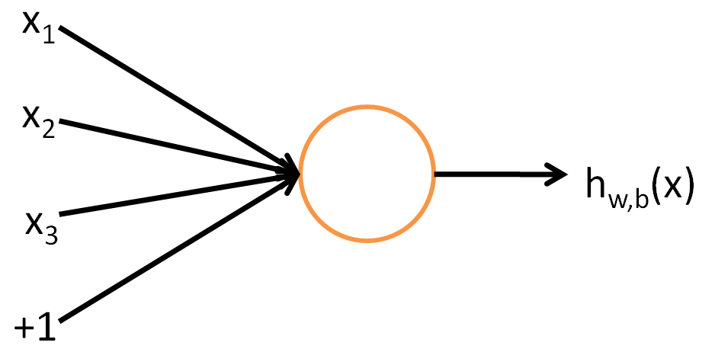

Figure 1: A single neuron[16]

A neural network is built by connecting may simple neurons together, so that the output of a neuron can be the input of another. An example of 3-layer neural network which has 1 input layer L1, 1 hidden layer L2 and 1 output layer L3.

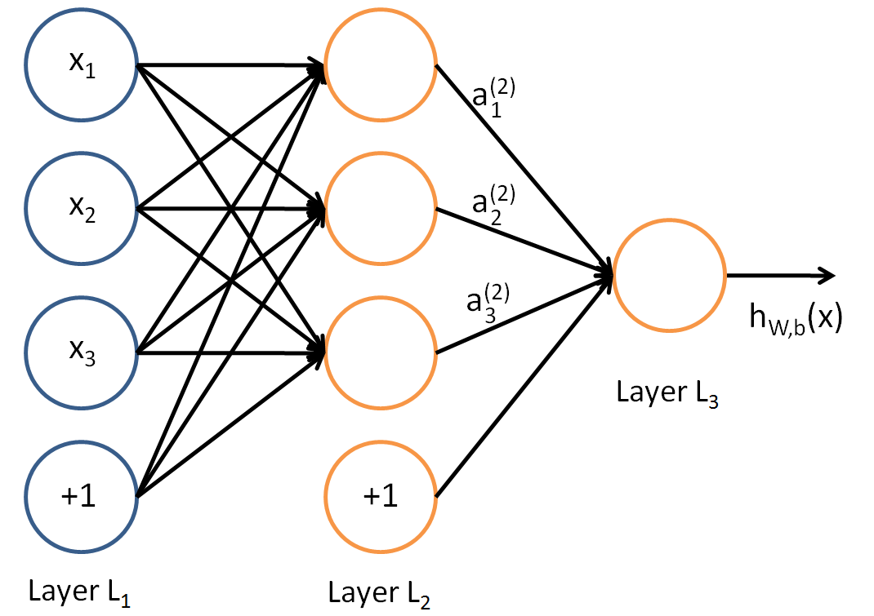

Figure 2: One layer neural network[16]

* Recurrent Neural Network: the idea of RNNs is to make use of sequential information. RNNs perform the same task for every element of a sequence with the output of a time step being deepened on the previous computation. It was said to be able to capture the temporal dynamics of financial time series[13]. This is an example of a recurrent neural network.

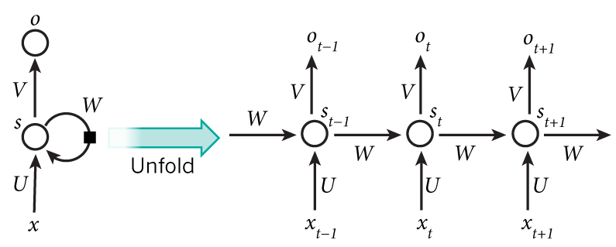

Figure 3: RNN and the unfolding in time of the computation involved in its forward computation

In the diagram:

$x_{t} is the input vector at time step t$

$s_{t}=f({Ux}_{t}+Ws_{t-1})$ is the hidden state at time step t.

$o_{t} is the output at time step t$

W is the weights matrix used to condition the output of the previous time step

U: is the weights matrix used to condition the input vector

In these approach, there are some aspect which needs to be addressed:

* Number of input units: the number of inputs unit depends on the number of input features selected from the data preprocessing step.
* Number of hidden layers and hidden units: these are hyper parameters the network which must be tested and fine-tuned during the implementation process.
* Activation function at each layer: a current popular choice is ReLU (Rectified Linear Unit) activation function which has been found much success to prevent exploding and vanishing gradient problem in training neural network[15]. There are also other activation functions such as tanh and Leakly ReLU which will be studied in the research.
* Learning rate: the training process heavily depends on the learning rate. When the cost function tends to converge to its minimum, the learning rate should be reduced in order to prevent fluctuation[10]. It is suggested to start with a small learning rate then decay it over time.
  1. **Performance metrics**:

The performance of the model can be asses using these metrics:

* Root mean Squared error (RMSE): it measures the different between predicted values and actual values

$$RMSE=\sqrt{\frac{1}{n}\sum_{i=1}^{n}{(y_{i}-{\hat{y}}_{i})}}$$

Where:

$n is the number of predictions$

$y_{i} is the i predicted value$

${\hat{y}}_{i} is the i actual value$

* Hit rate: it measures the accuracy of the prediction of tomorrow’s closing price compared to today. It values in the range between 0 and 1 where 1 denotes all the trends predicted correctly, 0 denotes all the trends are predicted incorrectly.

$$RMSE=\frac{1}{n}\sum_{i=1}^{n}{u[\left({{\hat{y}}_{i}-y}_{i-1}\right)\left(y_{i}{-y}_{i-1}\right)]}$$

Where:

$n is the number of predictions,$

$y_{i} is the i predicted value$

${\hat{y}}_{i} is the i actual value$

1. **Tasks**:

These tasks are created to with the intention to successfully achieve research objectives

|  |  |  |
| --- | --- | --- |
| Tasks | Description | Duration |
| T1 | Selecting topic | 2 weeks |
| T2 | Understanding the selected topic | 2 weeks |
| T3 | Exploring literature | 3 weeks |
| T4 | Establishing research questions | 3 weeks |
| T5 | Finding related learning and background materials | 5 weeks |
| T6 | Forming objectives and expected goal | 1 week |
| T7 | Learning the target companies and business sectors | 5 weeks |
| T8 | Establishing initial design ideas | 6 weeks |
| T9 | Research Plan | 1 week |
| T10 | Presentation 1 | 2 weeks |
| T11 | Report 1 | 1 week |

1. **Research timeline**:

The timeline is created in order to fulfill research’s goal and main objectives in section 4.2 as well as minor objectives arose as the research progresses

|  |  |  |  |
| --- | --- | --- | --- |
| Objectives | Task | Activity | Expected completion date |
|  | T1 | Select research topic from proposal list | Completed |
| Learn how to carry out a research | T2 | Research information related to topics of interest | Completed |
| Gain background knowledge about the research topic | T3 | Research up-to-date literature related to stock price prediction in general and stock price prediction using ANNs in particular | Completed |
| Learn how to carry out a research | T4 | Form a research questions based on proposed research topic and collected literatures | Completed |
| **Research Objective 1** | T5 | Study the target stocks and neural network | Ongoing |
|  | T6 | Forming objectives and expected goal | Completed |
| **Research Objective 2** | T8 | Create a draft design based on learnt information about stocks and proposed techniques | Ongoing |
| Learn how to carry out a research | T9 | Establish a research plan | Completed |
|  | T10 | Presentation | May-22 |
|  | T11 | Report | May-29 |

Gantt chart of research time line

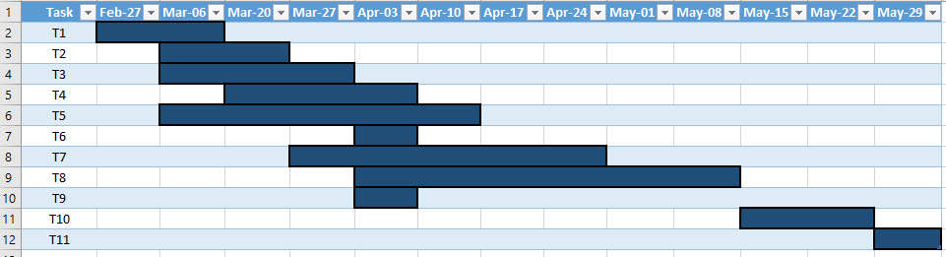

# Bibliography

[1] N. L. D. Khoa, K. Sakakibara, and I. Nishikawa, "Stock Price Forecasting using Back Propagation Neural Networks with Time and Profit Based Adjusted Weight Factors," in *2006 SICE-ICASE International Joint Conference*, 2006, pp. 5484-5488.

[2] G. Tingwei, L. Xiu, C. Yueting, and T. Youhua, "Deep learning with stock indicators and two-dimensional principal component analysis for closing price prediction system," in *2016 7th IEEE International Conference on Software Engineering and Service Science (ICSESS)*, 2016, pp. 166-169.

[3] W. Lertyingyod and N. Benjamas, "Stock price trend prediction using Artificial Neural Network techniques: Case study: Thailand stock exchange," in *2016 International Computer Science and Engineering Conference (ICSEC)*, 2016, pp. 1-6.

[4] M. Ballings, D. Van den Poel, N. Hespeels, and R. Gryp, "Evaluating multiple classifiers for stock price direction prediction," *Expert Systems with Applications,* vol. 42, no. 20, pp. 7046-7056, 11/15/ 2015.

[5] X. Zhong and D. Enke, "Forecasting daily stock market return using dimensionality reduction," *Expert Systems with Applications,* vol. 67, pp. 126-139, 1// 2017.

[6] Y. Chen and Y. Hao, "A feature weighted support vector machine and K-nearest neighbor algorithm for stock market indices prediction," *Expert Systems with Applications,* vol. 80, pp. 340-355, 9/1/ 2017.

[7] D. Enke and S. Thawornwong, "The use of data mining and neural networks for forecasting stock market returns," *Expert Systems with Applications,* vol. 29, no. 4, pp. 927-940, 11// 2005.

[8] M. M. Mostafa, "Forecasting stock exchange movements using neural networks: Empirical evidence from Kuwait," *Expert Systems with Applications,* vol. 37, no. 9, pp. 6302-6309, 9// 2010.

[9] S. Kumar Chandar, M. Sumathi, and S. N. Sivanandam, *Prediction of Stock Market Price using Hybrid of Wavelet Transform and Artificial Neural Network* (2016). 2016.

[10] J. C. Patra, N. C. Thanh, and P. K. Meher, "Computationally efficient FLANN-based intelligent stock price prediction system," in *2009 International Joint Conference on Neural Networks*, 2009, pp. 2431-2438.

[11] F. A. d. Oliveira, L. E. Zárate, M. d. A. Reis, and C. N. Nobre, "The use of artificial neural networks in the analysis and prediction of stock prices," in *2011 IEEE International Conference on Systems, Man, and Cybernetics*, 2011, pp. 2151-2155.

[12] M. Qiu, Y. Song, and F. Akagi, "Application of artificial neural network for the prediction of stock market returns: The case of the Japanese stock market," *Chaos, Solitons & Fractals,* vol. 85, pp. 1-7, 4// 2016.

[13] M. T. Motlagh and H. Khaloozadeh, "A new architecture for modeling and prediction of dynamic systems using neural networks: Application in Tehran stock exchange," in *2016 4th International Conference on Control, Instrumentation, and Automation (ICCIA)*, 2016, pp. 196-201.

[14] <https://www.tensorflow.org/>. (06-04). Available: <https://www.tensorflow.org/>

[15] R. Socher. (06-04). *CS224d: Deep Learning for Natural Language Processing*. Available: <http://cs224d.stanford.edu/lecture_notes/notes3.pdf>

[16] A. Ng, J. Ngiam, C. Y. Foo, Y. Mai, and C. Suen. (06-04). *Unsupervised Feature Learning and Deep Learning Tutorial*. Available: <http://deeplearning.stanford.edu/wiki/index.php/UFLDL_Tutorial>